Guidelines for Authors
The journal Análisis Geográficos publishes research articles, review articles, methodological papers, and case studies. It also publishes short notes, documents, and book reviews, offering a comprehensive platform for the exchange of knowledge in these fields.
When submitting a manuscript, it is assumed that the content has not been previously published and is not under review by another journal. If the manuscript is based on a thesis or research work submitted for an academic degree and is hosted in an institutional repository, a letter from the institution endorsing the manuscript and authorizing the publication of the results must be submitted. Additionally, the Declaration of Originality and Acceptance of Ethical Considerations must be reviewed to ensure compliance with ethical standards.
Please read the guidelines carefully and follow the recommendations provided so that the manuscript meets the journal’s standards and proceeds to the peer review process, editorial production, and publication.

TYPES AND BASIC STRUCTURE
Manuscripts intended for publication must follow a basic organizational structure in accordance with one of the following cases:
  - RESEARCH ARTICLE:
This document presents detailed original results from completed research projects.
In Geographic Analysis, use the IMRaD structure, which is generally organized as follows:
- Title: The title should be clear, concise, and reflect the main focus of the study; it should be no more than 20 words.
- Abstract: It should include the background or research question, the objective or purpose of the study, the methodology, the contributions, the results or findings, and the conclusions.
- Keywords: These are key terms that describe the main content of the text. When selecting keywords, use specialized thesauri as needed, list them alphabetically, and separate them with a comma (,). Include a minimum of 5 and a maximum of 7 words, and use words other than those in the title to help search engines.
- Introduction: Provides an overview of the study’s context and the significance of the research problem or question; clearly defines the research objective or hypotheses; summarizes the current state of knowledge on the topic; and explains why the study is necessary.
- Methodology: defines the research design, population, sample, procedures, techniques, measurement instruments, and methods of analysis.
- Results: Present the main findings of the research using tables and figures, and provide a detailed analysis of the results without interpretation; the presentation should be clear and straightforward.
-  Discussion: Analyze and interpret the results in the context of the research question and the existing literature; compare the findings with previous studies and discuss the similarities and differences, as well as the theoretical, practical, and/or policy implications of the findings; identify and discuss the study’s limitations and how they might affect the results; provide recommendations for future research based on the findings and the study’s limitations.
- Conclusions: Summarize the study’s main ideas, findings, and reflections, as well as its relevance, and explain how the study contributes to existing knowledge in the field.
Reference list: provides a complete list of all sources cited in the article, following the citation and reference format specified in the latest edition of the American Psychological Association (APA) Publication Manual.

  - REVIEW ARTICLE:
This document is the result of completed or ongoing research that analyzes, systematizes, and synthesizes published or unpublished research findings in a specific field or area of knowledge, with the aim of disseminating advances and trends in that particular area.
It provides a comprehensive and critical overview of the existing literature on a specific topic. Its structure is like that of a research article, differing in its careful and rigorous review of the literature on the topic, with the following considerations:
- The methodology must specify the criteria used to select the studies reviewed, including the databases consulted, as well as the process followed to analyze and synthesize the information from the selected studies.
- The body of the article should be organized into thematic sections or relevant subtopics; each section should summarize, analyze, and discuss the findings of the existing literature on the topic. Additionally, comparisons and contrasts of different studies and approaches should be made when deemed relevant, identifying trends, controversies, and gaps in the research, or analyzing the methods used in the reviewed studies and their results, evaluating their quality and applicability.
- The conclusions must include a synthesis of the findings derived from the review and consistent with the stated objective, as well as implications and recommendations for future research.
Please note that a review article must include at least 50 direct and indirect references. Only in fields of very recent development will we consider accepting review manuscripts with fewer references. Citations and references must follow the guidelines set forth in the latest edition of the American Psychological Association (APA) Publication Manual.
  - METHODOLOGY SECTION:
This document focuses on detailing the procedures, techniques, and tools used to conduct a research study. Its structure should be clear and systematic so that other researchers can replicate or understand the approach taken. The general structure is as follows:
- Title: The title should be specific and clearly reflect the methodological approach or the subject of the study.
- Abstract: This is a brief paragraph describing the methodology used, including the study’s objectives, the methodological approach, and the main procedures and techniques employed.
- Keywords: These are central terms that describe the main content of the text. When selecting keywords, use specialized thesauri as needed, organize them alphabetically, separate them with a comma (,), include a minimum of 5 and a maximum of 7 words, and use words different from the title to aid search engines.
- Introduction: defines the context of the study and explains why the specific methodological approach was chosen; defines the purpose of the methodology article, which may include a description of a new method, a comparison of existing methods, or a justification of the chosen methodology.
- Description of the method: This section should explain the general approach of the method and justify its selection, describe the research design used (experimental, correlational, descriptive, etc.), and outline the steps followed in implementing the method, from data collection to analysis.
- Data collection methods: Describe the instruments and techniques used for data collection and explain the procedures.
- Data analysis methods: Detail the methods, techniques, and software used.
- Ethical considerations: Describe how informed consent was obtained from participants and explain the measures taken to ensure confidentiality and the ethical handling of data, if applicable.
- Results and validation: (if applicable), present the preliminary results of the study if the article also includes an analysis of the results obtained using the described method, and describe how the method was validated (e.g., reliability and validity tests, pilot studies, etc.).
- Discussion: present an analysis or comparison of the research results in light of existing or potential findings, outline the strengths and limitations of the methodological approach used, and explore the implications of the methodology for future research and practical applications.
- Conclusions: summarize the key aspects of the methodological approach and its effectiveness and provide recommendations for the application or improvement of the methodology in future studies.
- References: provides an ordered list of references consulted, following the citation and reference format of the American Psychological Association (APA) Publication Manual, latest edition.
  - CASE STUDY ARTICLE:
It is designed to examine a specific case in depth and detail, offering insights, perspectives, and lessons learned that can be applied to similar situations. The typical structure of a case study differs from the previous structures in the following ways:
- Introduction: presents the general context of the case study, explains why the case is relevant and how it can contribute to existing knowledge, and defines the specific objectives of the case study and the research questions it seeks to answer.
- Case Description: Provides detailed information about the case, including background, historical and situational context, and the specific events, processes, or circumstances of the case; it also includes relevant information about the actors, resources, and key situations involved.
- Methodology: This section is structured similarly to that of a research article.
- Results: This section presents the key findings derived from the case analysis, using data and evidence, and identifies emerging themes and patterns from the case study.
- Discussion: analyzes the findings in the context of the case, relating them to the existing literature and the study’s objectives; discusses the implications of the results for theory, practice, and decision-making; and compares the case with other similar cases, if relevant, to highlight similarities, differences, and lessons learned.
- Conclusions: Summarize the key findings from the case study and provide recommendations based on these findings for future practice, policy, or further research.
- A complete list of all sources cited in the article must be provided, following the citation and reference format outlined in the latest edition of the American Psychological Association (APA) Publication Manual.
NOTES AND DOCUMENTS:
This category appears less frequently in scientific journals. It refers to works with flexible approaches that do not necessarily include empirical results, but rather reflections, data compilation, observations, and brief descriptions of methods or results. These notes report the results of small studies, research progress, or news of scientific interest. According to the Ministry of Science, Technology, and Innovation (MinCiencias, 2024), scientific notes are also considered preliminary results of observations or short studies that contribute new knowledge or hypotheses for future research. It is important to note that notes in scientific journals are considered secondary output relative to full-length articles.
  - REVIEW:
This is a text that outlines the general characteristics of a work and evaluates it critically. To write one, you must analyze the text in question in depth and comprehensively; you should ask questions about the author’s intent and the methodology used. The structure of a review includes:
- Title: Must include the author’s name, the title of the work, the place of publication, the publisher, the publication date, and the number of pages.
- Introduction: The first paragraph should indicate the original language of the work, the language into which it has been translated, and the translator’s name.
- Summary: Briefly describe the work, the author, and their approach. This section should include two elements: a clear and concise description of the topics covered and a list of the sources used by the author.
- Personal Assessment: Here, the reviewer offers an evaluation of the work’s strengths and limitations, highlighting both its strengths and weaknesses. It is important that this section be written clearly, concisely, and objectively, avoiding derogatory or excessively critical language.
- References: This section must include the bibliographic references consulted to validate the review, following the citation and reference format of the American Psychological Association (APA) Publication Manual, latest edition, and situate the work under review in its temporal and spatial context.
- Identification: Provides the reviewer’s details, including name, institutional affiliation, institutional email address, city, country, and ORCID number.

BASIC INFORMATION AND FORMAT
The first page of the manuscript or title page must include:
- Author information: institutional affiliation, institutional email address, ORCID ID, mailing address, and an academic profile of at least 50 words and no more than 80.
- The name of the corresponding author must be specified.
- The title of the article.
- A statement of conflicts of interest, if any.
- Acknowledgments, if any.
If the manuscript is the result of funded research, the name and code of the project must be provided, along with details of the supporting institution. This information should be presented on a separate page and must not appear in the main body of the manuscript
The text must be submitted in letter format with 3 cm left/right margins and 2.5 cm top/bottom margins, 1.5 line spacing, 8-point paragraph spacing, and 12-point Times New Roman font. URLs must be highlighted with underlining.
The minimum word count is 6,000 and the maximum is 8,000. This length includes tables, figures, and references. For reviews, the maximum length is 8 pages, 2,000 words, including the reference list.

DOCUMENT METADATA
The manuscript must include a title, abstract, and keywords. These elements should enable any reader to understand what the article is about and what findings it presents.
 Regarding the Title: Crafting an article’s title is essential for capturing readers’ attention and clearly communicating the study’s content, as follows:
- Reflejar con exactitud el contenido.
- Use clear and specific language to describe the approach.
• Limit the description to 20 words or fewer, ensuring that the information is sufficient to cover the main topic of the article.
• Consider a structure that may include the main problem, the method, and the result or conclusion, for example: “Effect of [independent variable] on [dependent variable] in [context]: a [research method] study” or “Impact of climate change on the biodiversity of tropical forests: a 20-year analysis in Central America.”
• Avoid abbreviations and technical terminology that may not be understandable to a broad audience.
- About the summary: It is a clear, comprehensive, and concise text that clearly explains the following:
- The problem statement.
• The objectives or purpose of the research.
• The methodology and methods used.
• The main findings and results.
• The conclusions of the paper.
• It should not include footnotes or bibliographic references, and its length should not exceed 250 words.
For keywords, you should:
• Choose terms that reflect the article’s main themes and concepts, which should be closely related to the research question, methods, and results.
• Include a mix of specific and general terms to attract both specialists and researchers with broader interests.
• Use keyword search tools, such as Google Scholar or field-specific databases, to find relevant terms and current trends.
• Use the UNESCO thesaurus.
Metadata must be provided in Spanish and English.

FIGURE FORMAT
All types of visual elements other than tables are considered figures. Every figure must provide valuable information within the context of the document, and it must be ensured that it is the best way to convey that information. As a journal policy, a maximum of 5 figures per article is allowed.
Figures must include the following components:
- Número de la figura en negrita: se enumera en el orden en que aparecen en el documento.
- Title: must appear on a line below the figure number, in italics, and without a period at the end.
- Figure: in accordance with the journal’s guidelines.
- Source: describes the origin of the figure.
- Note: any content that needs to be explained and cannot be understood solely from the title or the image itself.
Example
Figure 1: Breakdown of the main inputs used in the assessment of mass movement and erosion
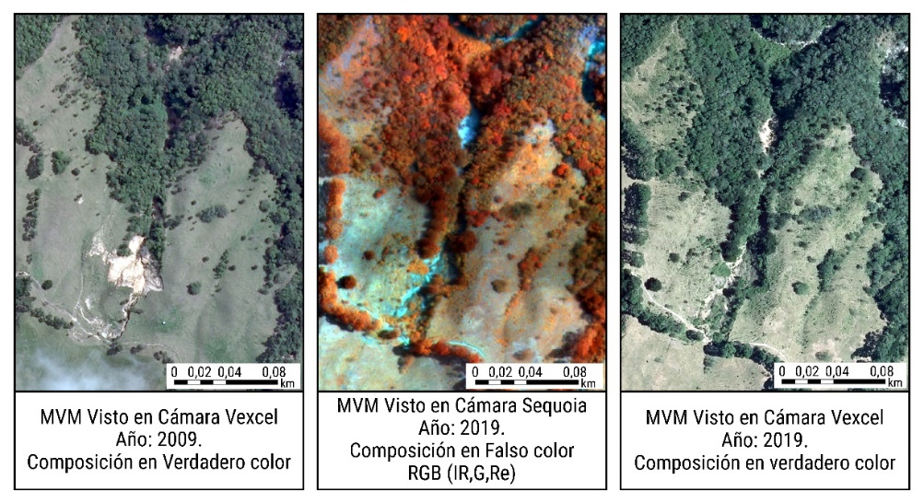
Source: Adapted from IGAC, 2019.
* MVM stands for mass movements.
Citation of figures in the text
Figures should be inserted into the text only after they have been mentioned. In other words, first make the relevant comment, referring to the figure by its number, and then include the corresponding figure in the text. This order ensures that the reader can easily follow the reference and understand the context of the figure within the document.
Example:
Both 2D and 3D data (digital stereoscopy) were used, so it was necessary to generate orthophotomosaics and photogrammetric blocks based on aerial photographs taken with the Vexcel Ultracam D camera (Figure 1). Approximately 90 stereoscopic pairs were interpreted for 2009 and 71 for 2019.

In addition, false-color composites were generated from the various orthophotomosaics. To enrich the analysis, the digital elevation model from the ALOS PALSAR satellite sensor, which has a spatial resolution of 12.5 meters, was also used, along with its derived products, such as slope and shadow maps. Figure 1 illustrates these composites in detail and their integration with the digital elevation model, providing a more comprehensive view of the geospatial data.

-Figure references
Figures are presumed to be the work of the author of the document. The source of the data used to create them must be cited. The reproduction of non-original figures—that is, those taken from another source—must be accompanied by a statement indicating that the figure has been reproduced, providing the original reference, and noting that it is subject to the conditions established by the copyright holder. This process is the responsibility of the article’s author. The referencing of figures in the text depends on whether they are original, an adaptation, or a reproduction.
In the case of a figure created by the author, the journal does not allow self-referencing; the source of the data used in its creation must be specified.
Figure 2 Location of the study area, Guaviare Department
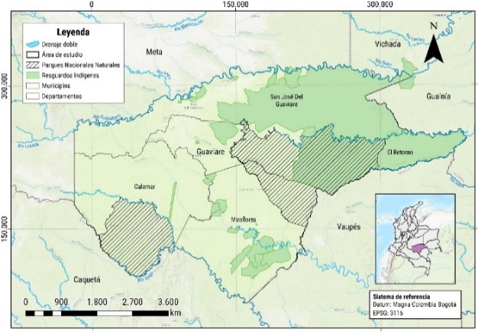
Data: National Land Agency Open Data Portal, July 5, 2024; IGAC Open Data on Cartography and Geography, 2024.

Example:
When a figure is reproduced or adapted, the copyright notice must be included, along with an entry in the list of references. This statement must appear at the bottom of the figure, clearly specifying the copyright credits.

Example:
Figure 3 Methodological Framework
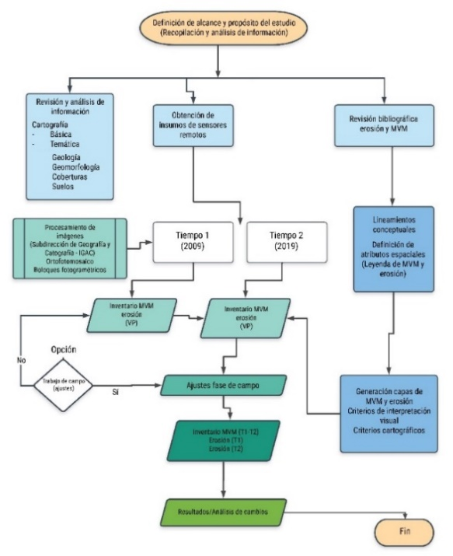
.
Source: Adapted from IGAC and CRQ, 2019

When the image is a photograph
Example:
Figure 4 Panoramic view of Lake Tota, Boyacá Department – Colombia
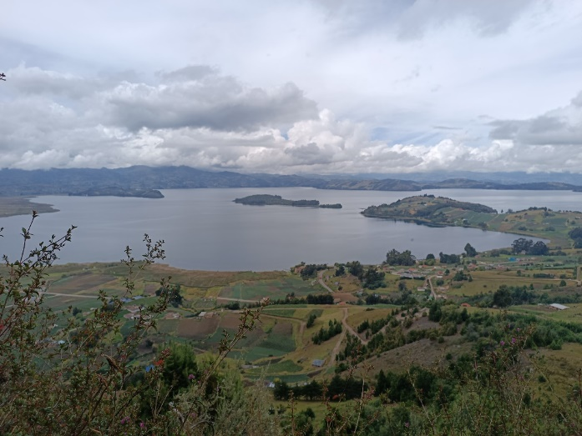
Photograph by Cadena-Montero, October 2023.

When it is a satellite image
Example:
Figure 5: Evolution of the gas and ash plume associated with the eruption of Galeras Volcano on September 30, 2009
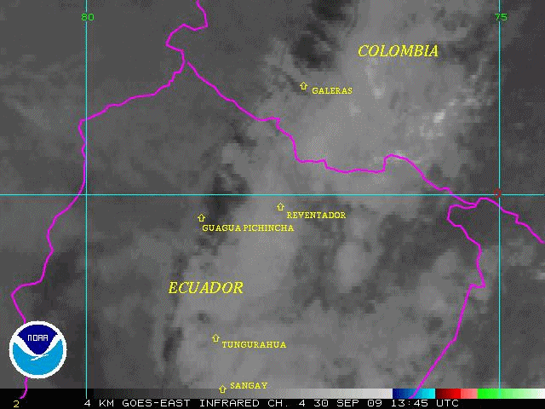
Source: GOES-EAST satellite imagery, infrared channel, 4 km per pixel resolution.
Note: This sequence of images illustrates the evolution of the gas and ash plume during the eruptive episode of Galeras Volcano, which began at 9:14 a.m. on September 30, 2009. These images cover the period from 8:45 a.m., before the eruption began, until 11:15 a.m., capturing the dynamic development of the volcanic event.
- When mapping is based on the interpretation of aerial photographs
Example:
Figure 6: Mosaic of aerial photographs of the rural area of Bogotá, D.C.
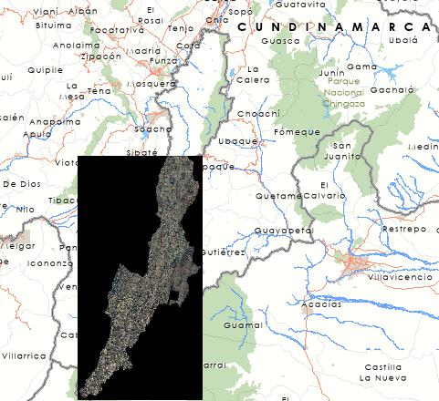
Source: Photo interpretation of flight C-3345, No. 5, January 2020.
Note: This product contains an orthorectified raster mosaic of the rural area of Bogotá, covering parts of the municipalities of Usme, Ciudad Bolívar, and Sumapaz, corresponding to approximately 103,000 hectares. It includes 4 bands of the electromagnetic spectrum:
red, green, blue, and near-infrared, enabling the creation of false-color imagery for forestry applications.
- Hand-drawn figures are accepted provided they are legible and scanned at the specified resolution.
- It is essential that all components (including the topology) of the figures be fully legible. While it is preferable that they conform in size and scale to the journal’s format (21.59 cm x 25 cm), in exceptional cases and depending on the type of figure, they may be published in larger formats to maintain the scale ratio and facilitate a better understanding of their components. Approval is at the discretion of the journal’s editor.
- All figures must be organized in a separate folder in PDF and JPG formats, as well as in an editable format (.ai, .xls, .doc, .ppt—as applicable—) with a minimum resolution of 600 dpi, properly named according to the numbering in which they appear in the text (Figure 1, Figure 2, Figure 3a, Figure 3b).
- In the case of maps, files should be submitted in PDF, JPG, and the cartographic project with its respective layers.
- Submitting figures in editable formats will ensure compliance with the journal’s guidelines and facilitate the workflow.

TABLE FORMAT
- Tables should be clear and provide additional information that complements the content of the manuscript, rather than repeating or summarizing it. They should be submitted in editable formats (docx or .xls), not as embedded images. Like figures, tables should include the following components (see Table 1 for an example):
- Table number: in bold, listed in the order in which it appears in the document, with a numbering system separate from that of the figures.
- Title: must appear on a line below the table number, in italics and without a period at the end.
- Source: describes the origin of the table.
- Note: supplementary description that cannot be understood or inferred solely from the title and content of the table; it provides details to facilitate understanding independently of the text. All abbreviations used in the table are explained in the note to ensure clarity and correct interpretation of the data. Units of measurement are listed in the first cell and are not repeated in each one.
- Units of measurement: use the International System of Units; express quantities using their official symbols (e.g., m for meter, kg for kilogram), without plural forms or a period. Leave a space between the number and the unit (e.g., 25 km, not 25km). In manuscripts written in Spanish, decimal numbers must be separated by a comma (,) and in English by a period (.). Use scientific notation for very large or small values (2.5 × 10⁶). Avoid non-standard abbreviations.

Table 1 Characteristics of remote sensing images from airborne platforms
Sensores aerotransportados
Sensor | Resolution | Bands | Spatial resolution (m) | Year of harvest | Coverage (%)
Vexcel Ultracam | Very high-submetrical | Blue (B), green (G), red (R), and near-infrared (IR). | 0,15 - 0,3 | 2009 | 100
 |  |  |  | 2019 | 76
Sequoia | Very high-submetrical | Green (G), red (R), red edge (Re), near-infrared (IR). | 0,49 | 2019 | 47

MAP FORMAT
The maps included in the manuscript must comply with the following cartographic standards:
- Title: Be self-explanatory; titles may not be included in the body of the map. Please refer to the examples provided.
- Geographic information: The geographic information and data depicted must be validated and cleaned by the author. If official or open data sources are used, they must be cited in the metadata.
- Coordinate grid: Depending on the Cartographic Reference System (CRS) used, choose either a grid or a coordinate system, depending on whether geographic or planar (projected) coordinates are used. If the manuscript contains multiple maps, it is recommended to standardize the coordinate grids to facilitate the reading of the depicted geographic features. Coordinates are expressed in thousands (840,000) or in minutes (-74°15’00”), as appropriate. The thousands represent longitudes in the metric system given in meters or kilometers, for plane coordinates. Degrees, minutes, and seconds follow the sexagesimal system of measurement for geographic coordinates.
- Legend and conventions: In accordance with cartographic and semiotic standards, maps include a legend that clearly describes the categories of geographic information. The legend is organized as follows: first the conventions, followed by the thematic information; within this section, point features are presented first, followed by lines, and finally areas. It is recommended to use ColorBrewer to select appropriate colors based on the nature of the variable being represented. Additionally, it is essential to adhere to the official object catalog of the corresponding country for the conventions.
- North arrow: Align with the grid or reticle, as applicable. Use simple arrows. The position and alignment of the north arrow should not be arbitrary.
- Graphic scale: since the maps will undergo an editing process and their original size may change, include only the graphic scale. For the composition of the graphic scale, adhere to the units of composition and use fixed, standard factors (e.g., 10,000, 25,000). The unit of composition is 1 centimeter.
- Please note that most GIS software is preset to 1 inch, so maps submitted with the default GIS scale will not be accepted. One way to validate the graphic scale is to compare it with the distances indicated on the grid.
- Borders and outlines: use simple lines that clearly distinguish the geographic information area, the coordinate grid, and the description and legend areas, if the map includes them. An external frame is not required. Review the sample maps to ensure proper layout of the components.
- Description: In the map caption, the author may choose to include a brief description to help the reader better understand the message presented in each map. This will be considered explanatory notes that facilitate reading the map.
- Geographic metadata: describe the official and open data sources used. Additionally, include a brief description of the Cartographic Reference System (SRC), mentioning only the main elements (datum, projection, units, EPSG code).
- EPSG code: Although this is part of the metadata, it is listed as a separate item so that authors prioritize its inclusion. This code is the most efficient way to provide readers with a complete description of the Cartographic Reference System. Furthermore, it allows this information to be presented concisely without cluttering the layout. If maps using different Cartographic Reference Systems are included, the corresponding code for each must be indicated.
- Map author: if the map was created by someone other than the article’s authors, their name must be included; otherwise, it should be omitted.
Example:

Figure 7 Map showing the distribution of the population aged 15 to 49 by block in Milla Central, 2024
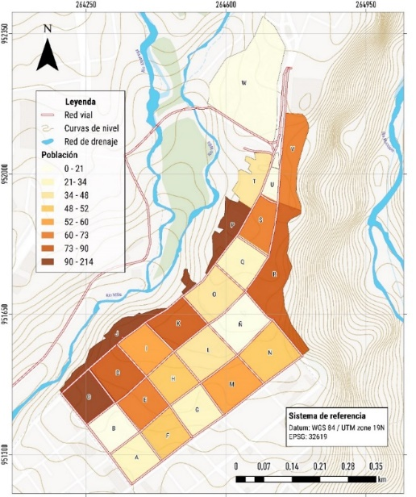
Source: Santiago and Cadena, 2024.

